17.VEHICLE REGISTRATION NUMBER REGISTRING SYSTEM

SEQUENCE DIAGRAM

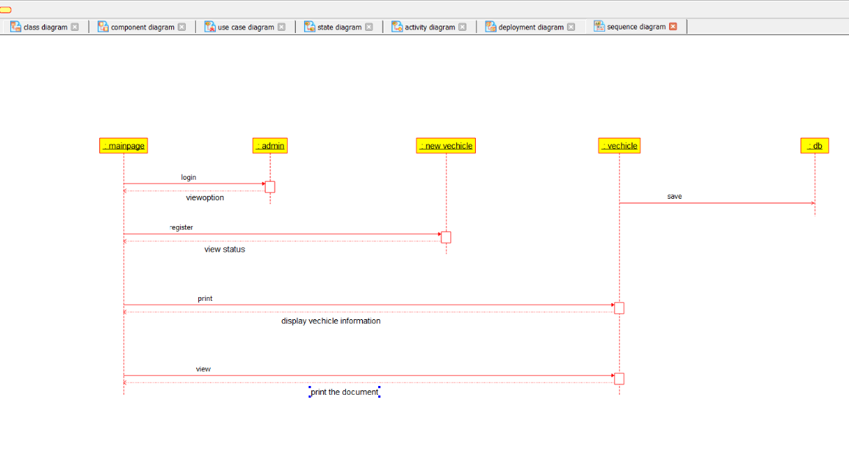

CLASS DIAGRAM

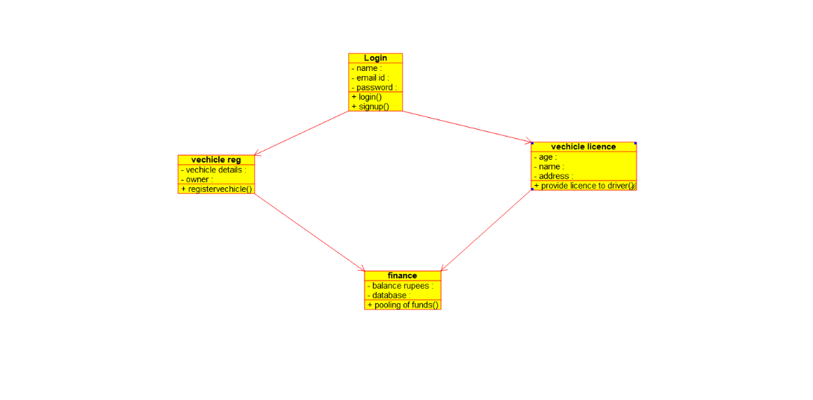

DEPLOYMENT DIAGRAM

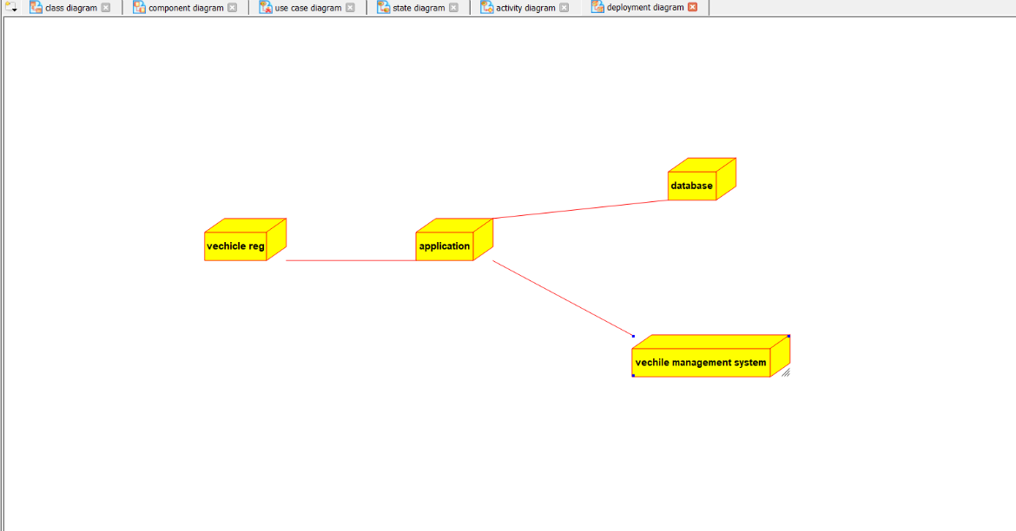

ACTIVITY DIAGRAM

